



Smart Payroll Analytics and Financial Optimization

Project Domain
[Excel / Power BI with Copilot]
A Collaborative Initiative
equipping students with practical skills in AI, Data Analytics, and Business Intelligence

by: Pooja Rohit Mandal
Student Name
Pooja Rohit Mandal


Guide
Umamaheswari

Student Email
poojaman776@gmail.com

Institution:
[Smt. MMP Shah Women’s College]
Year - 2026

3. Problem Statement
1. Payroll Data Accuracy & Validation
Problem: Organizations face inaccurate payroll calculations due to incorrect formulas, leading to wrong salary payouts and financial inconsistencies.
What it is: Analyze payroll data to validate salary calculations (Gross & Net Salary), detect mismatches, and ensure accurate payroll processing.
2. Duplicate Records & Data Integrity
Problem: Duplicate employee records can result in double payments and financial loss.
What it is: Identify and eliminate duplicate Employee IDs to maintain data integrity and ensure each employee is paid correctly.
3. Department-wise Payroll Cost Analysis
Problem: Lack of visibility into department-wise salary expenses affects budgeting and cost control.
What it is: Analyze payroll distribution across departments to identify high-cost areas and optimize workforce spending.
4. Salary Structure & Pay Equity Analysis
Problem: Unequal salary distribution across departments may create internal pay imbalance and dissatisfaction.
What it is: Evaluate average salaries, salary variance, and identify disparities across departments.

5. Deduction & Compliance Monitoring
Problem: Incorrect or inconsistent deductions can lead to compliance issues and financial risks.
What it is: Analyze deduction patterns and ratios to ensure proper tax and statutory compliance.
6. Bonus & Overtime Cost Optimization
Problem: Uncontrolled bonus and overtime expenses can increase payroll costs unnecessarily.
What it is: Evaluate bonus percentage and overtime contribution to total payroll for cost optimization.
7. Payroll Data Consistency & Error Detection
Problem: Inconsistent payroll data reduces reliability of financial reporting.
What it is: Detect calculation errors and inconsistencies in payroll data for accurate financial analysis.

4. Objectives
- To understand the structure and components of the payroll dataset.
- To clean and preprocess the payroll data by removing inconsistencies and validating calculations.
- To ensure data integrity by checking duplicates, validating formulas, and standardizing fields.
- To perform financial analysis on payroll data using Excel.
- To identify key payroll trends such as department-wise salary distribution, deductions, and bonuses.
- To generate business KPIs for effective payroll management.
- To provide actionable insights for cost control, compliance, and workforce planning.
- To present findings in a structured and professional analytical format.

5. Methodology / Implementation Plan

# | Phase | Description
1 | Data Collection & Exploration | The payroll dataset was obtained in Excel format. Key fields such as Employee ID, Department, Salary Components, and Deductions were identified. Financial relationships like Gross Salary and Net Salary were understood.
2 | Data Cleaning & Preprocessing | Duplicate records were checked (no duplicates found). Salary formulas were validated and 406 incorrect Net Salary calculations were identified. Department names were standardized and deduction values were verified.
3 | Data Analysis | Data was analyzed using Excel functions. Department-wise payroll cost, salary averages, deductions, and trends such as bonus percentage and overtime cost were evaluated.
4 | KPI Development | - Total Payroll Cost  - Net Payroll Cost  - Average Salary per Department  - Bonus Percentage  - Deduction Ratio  - Payroll Growth Rate  - Overtime Cost Percentage

6. Resources and Timeline

A. Hardware & Software Requirements
- Laptop or PC — Intel Core i3 or higher, minimum 4 GB RAM (8 GB recommended)
- Operating System: Windows 10 / 11 or macOS
- Microsoft Excel (Microsoft 365 / Excel 2019 or later)
- Power BI Desktop — latest version (free download from Microsoft) — where applicable
- Microsoft Copilot — via Microsoft 365 subscription — where applicable
- AI Chatbot (Microsoft Copilot Web) — for prompt-based projects
- Internet connection — required for Copilot and AI Chatbot access
- Web browser — Google Chrome or Microsoft Edge (latest version)

B. Dataset
The dataset used for this project is an Employee Payroll Dataset containing detailed information on employee compensation, salary components, and deductions. The dataset is available in Excel format and serves as the primary source for data cleaning, financial analysis, and KPI generation.
The dataset includes important fields such as Employee ID, Department, Designation, Basic Pay, Allowances, Overtime Amount, Deductions, Gross Salary, Net Salary, Pay Month, and Subdivision. Each record represents an individual employee’s payroll details for a specific period.
The dataset follows standard payroll calculation logic:
- Gross Salary = Basic Pay + Allowances + Overtime
- Net Salary = Gross Salary – Deductions
These calculations were validated during the data cleaning process to ensure accuracy and consistency.
The dataset was analysed to identify data quality issues such as duplicate records, incorrect salary calculations, and inconsistencies in department naming. It was found that there were no duplicate records, ensuring data integrity, but 406 records had incorrect Net Salary calculations, indicating the need for correction before final reporting.
This dataset enables the analysis of department-wise payroll costs, salary distribution, deduction patterns, bonus allocation, and overtime expenses, which are essential for financial control and decision-making.
Overall, the dataset provides a strong foundation for generating business insights, monitoring payroll performance, and improving data accuracy and compliance within the organization.

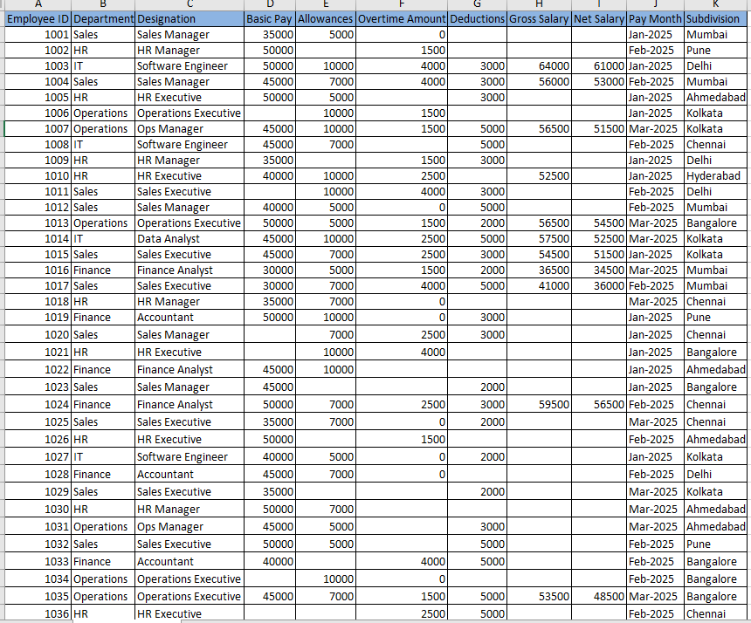
UNCLEANED DATASET

CLEANED DATASET

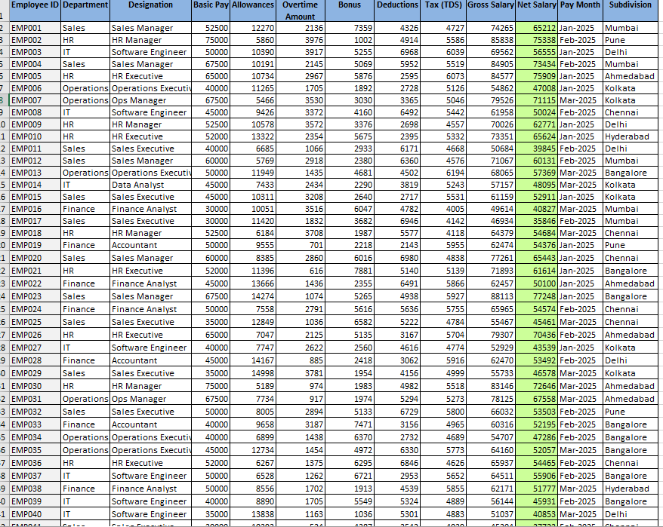

C. Project Timeline
A simple table showing planned tasks and expected completion dates.
Phase | Task | Tentative Completion Date

C. Project Timeline
A simple table showing planned tasks and expected completion dates.
Phase | Task | Tentative Completion Date
1 | Data Collection & Exploration | Week 1
2 | Data Cleaning & Validation | Week 2
3 | Data Analysis & KPI Development | Week 2-3
4 | Insights Generation and reporting | Week 3
5 | Final Documentation & Submission | Week 4

7. Expected Business Outcomes / Conclusion
This project is expected to deliver a comprehensive and structured analysis of employee payroll data by applying data cleaning, validation, and financial analysis techniques.
The key Business outcomes are:

1. Payroll Accuracy Improvement
Identifies incorrect salary calculations using Excel (formula validation) and ensures accuracy through data cleaning.
Improves payroll reliability by correcting Net Salary mismatches.
Enables error-free payroll reporting for financial decision-making.
2. Data Integrity & Risk Reduction
Detects duplicate records using Excel validation techniques.
Ensures unique Employee IDs to prevent double payments.
Strengthens internal financial controls and reduces payroll risk.

3. Department-wise Cost Optimization
Analyzes payroll cost distribution using Excel (pivot tables) and Power BI dashboards.
Identifies high-cost departments like Operations for better budgeting.
Supports strategic workforce and cost management decisions.
4. Salary Structure Transparency
Evaluates average salary and variance across departments using Excel analysis.
Highlights pay disparities (e.g., HR having highest salary levels).
Helps management maintain fair and competitive compensation structures.

5. Compliance & Deduction Monitoring
Tracks deduction ratios using Excel calculations and dashboards.
Identifies departments with high deduction burden.
Ensures compliance with financial and tax regulations.
6. Bonus & Overtime Efficiency
Measures bonus percentage and overtime cost using Excel KPIs.
Ensures controlled spending on incentives and extra work hours.
Supports cost-efficient payroll planning.

7. Data Quality & Decision Support
Detects salary calculation errors using Excel validation checks.
Improves data quality for accurate reporting and analysis.
Enables better decision-making through reliable payroll insights.

Overall, the project enhances payroll accuracy, financial transparency, and decision-making capability by transforming raw payroll data into meaningful business insights. The findings can support management in optimizing workforce costs, ensuring compliance, and improving operational efficiency.

8. References
The following resources and materials were referred to during the development of this project:
• Edunet Foundation. AICW Fellowship Program Guidelines. 2026.
• Microsoft Corporation. Microsoft Excel Documentation. Available at: https://support.microsoft.com/excel
• Microsoft Corporation. Power BI Documentation. Available at: https://learn.microsoft.com/power-bi
• Kaggle Inc. Open Datasets. Available at: https://www.kaggle.com/datasets
• Online Data Analytics Tutorials and Learning Resources
• Payroll Management Concepts and Financial Analysis Materials

